📄 Hotel Booking Cancellation Prediction Report

1️⃣ Introduction
Hotel booking cancellations represent a significant challenge for hotel management. High cancellation rates can negatively affect revenue, room utilization, and operational planning such as staffing and inventory management.
This project aims to address this issue by applying supervised machine learning techniques to predict whether a booking will be canceled. By identifying cancellation patterns, hotels can make better business decisions and reduce potential losses.

2️⃣ Problem Description
Hotels often face uncertainty due to last-minute booking cancellations. This creates several problems:
- Loss of expected revenue
- Inefficient room allocation
- Difficulty in planning staff and resources
- Risky overbooking decisions
To solve this problem, we aim to build a predictive model that can determine whether a reservation will be canceled or not based on historical booking data.

3️⃣ Dataset Description
The dataset used in this project is the Hotel Booking Demand dataset, which contains booking information for both City Hotel and Resort Hotel.
Link dataset
Each record represents a single booking, and the target variable is:
- is_canceled
  - 1 → Booking was canceled
  - 0 → Booking was not canceled
Features include:
- Booking lead time
- Meal type
- Market segment
- Distribution channel
- Average Daily Rate (ADR)
- Number of special requests
- Customer type
- Room assignment details
This dataset is suitable for a binary classification problem, where the goal is to predict a yes/no outcome.

4️⃣ Project Objective
The main objective of this project is to build and compare multiple machine learning classification models to predict booking cancellations.
Specifically, the project aims to:
- Clean and preprocess the dataset
- Explore relationships between features and cancellations
- Train multiple classification models
- Evaluate model performance using appropriate metrics
- Select the best-performing model

5️⃣ Data Cleaning and Preprocessing
Before training the models, several preprocessing steps were applied:
- Removed duplicate records
- Dropped irrelevant or highly missing columns
- Handled missing values using appropriate techniques
- Encoded categorical variables
- Scaled numerical features where necessary
These steps ensured higher data quality and improved model performance.

6️⃣ Exploratory Data Analysis (EDA)
Exploratory analysis was conducted to understand patterns in the data.
Key observations include:
- Bookings with longer lead times are more likely to be canceled
- Higher ADR values sometimes correlate with cancellations
- Customers with more special requests are less likely to cancel
- Certain market segments have higher cancellation rates
EDA helped identify important features influencing the target variable.

7️⃣ Model Implementation
Several supervised machine learning models were trained, such as:
- Logistic Regression
- Decision Tree
- Random Forest
Each model was trained on the processed dataset and evaluated using the same conditions for fair comparison.

8️⃣ Model Evaluation
Models were evaluated using metrics such as:
- Accuracy
- Precision
- Recall
- F1-score
These metrics help measure how well each model predicts cancellations, especially in cases where class imbalance may exist.

9️⃣Results and Comparison
After training and evaluation:
- Some models performed better in accuracy
- Others provided better recall (important for detecting cancellations)
The best model was selected based on overall performance and its usefulness for business decisions.

11️⃣ Code Documentation
The code includes inline comments (#) explaining each step:
- Data cleaning
- Preprocessing
- Visualization
- Model training
- Evaluation
This ensures the workflow is clear and easy to understand.
Evaluation :
1_Models Performance (Before Feature Selection)
Model | Accuracy | Precision | Recall | F1-score
Logistic Regression | 0.7920 | 0.8218 | 0.5606 | 0.6665
Decision Tree | 0.7901 | 0.8301 | 0.5455 | 0.6583
Random Forest | 0.8814 | 0.8728 | 0.7962 | 0.8327

2_ModelsPerformance (After Feature Selection)
Model | Accuracy | Precision | Recall | F1-score
Logistic Regression | 0.7644 | 0.8277 | 0.4604 | 0.5917
Decision Tree | 0.7746 | 0.7495 | 0.5889 | 0.6596
Random Forest | 0.8090 | 0.7716 | 0.6886 | 0.7277

Random Forest achieved the best performance among all models, providing the highest accuracy and a strong balance between precision and recall.
Before feature selection, Random Forest achieved the highest performance with an accuracy of 88.1% and strong recall. After reducing the number of features, the model performance slightly decreased across most metrics.
This indicates that while feature selection helped simplify the model and reduce dimensionality, some important information may have been lost, which affected performance.
However, feature selection still provides benefits such as reducing model complexity, improving training speed, and helping focus on the most important features.

Feature Importance
- lead_time
- country
- deposit_type
- adr
- market_segment
- total_of_special_requests
- total_stay
- previous_cancellations
- customer_type

Feature importance analysis was performed using the Random Forest model.
The most important features affecting booking cancellation include:
- Lead Time: Longer lead times increase the likelihood of cancellation.
- Deposit Type: Customers with no deposit are more likely to cancel.
- ADR (Average Daily Rate): Pricing influences cancellation behavior.
- Market Segment: Different customer groups behave differently.
- Number of Special Requests: More requests indicate higher commitment.
These features help explain customer behavior and improve decision-making in hotel management.

ColabLink
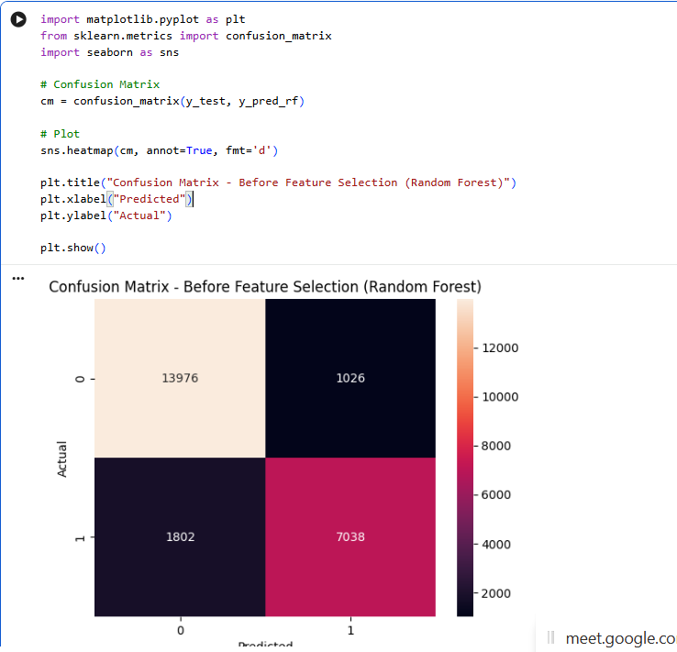
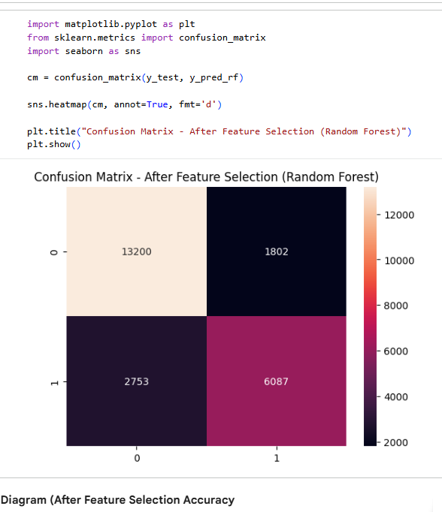
🔟 Conclusion
This project successfully applied machine learning techniques to predict hotel booking cancellations.
The selected model can help hotels:
- Anticipate cancellations
- Improve revenue management
- Optimize booking strategies
Future improvements may include:
- Using more advanced models
- Hyperparameter tuning
- Deploying the model in a real-world system

